Create Custom Shapes Like Square, Circle, Triangle, Rectangle, Oval in React Native

This is an Example to Create Custom Shapes Like Square, Circle, Triangle, Rectangle, Oval in React Native. In this example, we will see how to make custom Shapes in React Native. This example will give you an idea about the basic shapes and will help you if you are making some basic 2D game or some other stuff which needs to have different shapes. So Let’s get started.

We are going to use StyleSheet to make different shapes and will set a different style on a view using different states.

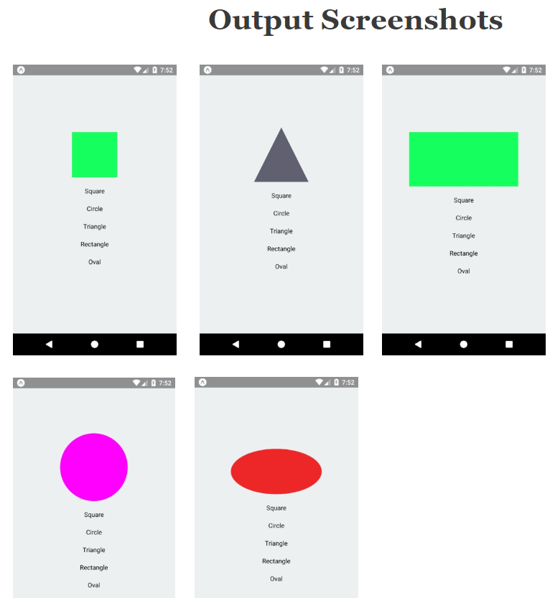

/\*This is an Example of React Native Create Custom Shapes Like Square,Circle, Triangle, Rectangle, Oval\*/

import React from 'react';

import { Text, View, StyleSheet, TouchableOpacity } from 'react-native';

export default class App extends React.Component {

constructor(props) {

super(props);

this.state = {

ShowSquare: false,

showCircle: false,

showTriangle: false,

showRectangle: false,

oval: false,

};

}

hideAll = () => {

this.setState({

ShowSquare: false,

showCircle: false,

showTriangle: false,

showRectangle: false,

showOval: false,

});

};

ShowSquare = () => {

this.hideAll();

this.setState({

ShowSquare: true,

});

};

showCircle = () => {

this.hideAll();

this.setState({

showCircle: true,

});

};

showTriangle = () => {

this.hideAll();

this.setState({

showTriangle: true,

});

};

showRectangle = () => {

this.hideAll();

this.setState({

showRectangle: true,

});

};

showOval = () => {

this.hideAll();

this.setState({

showOval: true,

});

};

render() {

return (

<View style={styles.container}>

<View

style={

this.state.ShowSquare

? styles.SquareShapeView

: this.state.showCircle

? styles.CircleShapeView

: this.state.showRectangle

? styles.RectangleShapeView

: this.state.showTriangle

? styles.TriangleShapeView

: this.state.showOval

? styles.OvalShapeView

: ''

}

/>

<TouchableOpacity onPress={this.ShowSquare} active={0.8}>

<Text style={{ marginTop: 20, fontSize: 20 }}>Square</Text>

</TouchableOpacity>

<TouchableOpacity onPress={this.showCircle} active={0.8}>

<Text style={{ marginTop: 20, fontSize: 20 }}>Circle</Text>

</TouchableOpacity>

<TouchableOpacity onPress={this.showTriangle} active={0.8}>

<Text style={{ marginTop: 20, fontSize: 20 }}>Triangle</Text>

</TouchableOpacity>

<TouchableOpacity onPress={this.showRectangle} active={0.8}>

<Text style={{ marginTop: 20, fontSize: 20 }}>Rectangle</Text>

</TouchableOpacity>

<TouchableOpacity onPress={this.showOval} active={0.8}>

<Text style={{ marginTop: 20, fontSize: 20 }}>Oval</Text>

</TouchableOpacity>

</View>

);

}

}

const styles = StyleSheet.create({

container: {

flex: 1,

alignItems: 'center',

justifyContent: 'center',

},

CircleShapeView: {

//To make Circle Shape

width: 150,

height: 150,

borderRadius: 150 / 2,

backgroundColor: '#FF00FF',

},

OvalShapeView: {

//To make Oval Shape

marginTop: 20,

width: 100,

height: 100,

backgroundColor: '#ED2525',

borderRadius: 50,

transform: [{ scaleX: 2 }],

},

SquareShapeView: {

//To make Square Shape

width: 100,

height: 100,

backgroundColor: '#14ff5f',

},

RectangleShapeView: {

//To make Rectangle Shape

marginTop: 20,

width: 120 \* 2,

height: 120,

backgroundColor: '#14ff5f',

},

TriangleShapeView: {

//To make Triangle Shape

width: 0,

height: 0,

borderLeftWidth: 60,

borderRightWidth: 60,

borderBottomWidth: 120,

borderStyle: 'solid',

backgroundColor: 'transparent',

borderLeftColor: 'transparent',

borderRightColor: 'transparent',

borderBottomColor: '#606070',

},

});